SUPREME COURT OF THE STATE OF NEW YORK COUNTY OF NASSAU  ------------------------------------------ | X
In the Matter of the Application of  FELIX PROCACCI,  Petitioner,  -against-  TOWN OF HEMPSTEAD  Respondent.  ------------------------------------------ | :  :  :  :  :  :  :  :  :  :  :  :  :  :  :  X | Index No.  615888/2018  AFFIDAVIT IN  OPPOSITION OF MOTION TO DISMISS  Justice Assigned:  Hon. Sharon M.J. Gianelli  Return Date: 01/09/2019
TO THE SUPREME COURT OF THE STATE OF NEW YORK, COUNTY OF NASSAU:
I Felix Procacci, being duly sworn, deposes and says:

- I am the Petitioner in this proceeding. Petitioner is appearing Pro Se in this matter. Petitioner makes this affidavit in opposition to the motion by the Respondent Town of Hempstead to dismiss the Petition challenging the legitimacy of the “Emergency Free Air Law”.
- The Respondent cites two reasons for dismissing this action. First, the Petitioner does not have standing, and second, this proceeding is improperly brought pursuant to an Article 78 because Petitioner is an unaggrieved party in this litigation.
- The Petitioner disagrees with the Respondent's arguments for dismissal.
- Each of these issues were discussed in the Petition (in items 27 through 33), and the Respondent chose not to respond directly to those statements.
- The Petitioner explained in the Petition, why he believes he has standing and why an Article 78 mandamus proceeding is appropriate in this case.
- For convenience those arguments, made in the Petition, will be repeated and expanded here to ensure that the Respondent is cognizant of the case law cited which allows an unaggrieved Citizen-Taxpayer to challenge the Constitutionality of a local law and bring this case with an Article 78 seeking a writ of mandamus.
- First, the Respondent argues that the Petitioner does not have standing because he is not specially aggrieved by the ordinance referred to as the “Emergency Free Air Law” in the petition and hereon after.
- Second, the Respondent argues that an Article 78 is improper for this proceeding as follows: “Mandamus to compel does not lie in the absence of a clear legal right to the relief sought, and there is no such right, petitioner's claims not withstanding.”
- This proceeding is challenging the Constitutionally of the “Emergency Free Air Law” claiming it violates the Fourteenth amendment to the United States Constitution as well as Town and State laws.
- The following statements cite case law from the second department that shows an unaggrieved Citizen-Taxpayer does have standing to challenge the Constitutionally of a local law.
Petitioner Has Standing
- An unaggrieved Citizen-Taxpayer has standing to Constitutionally challenge a local law (see St. John's Law Review, Issue 1, Volume 39, December 1964, Number 1). Referenced portion is attached hereto as Exhibit 1.
- The Petitioner is an unaggrieved citizen-taxpayer in this matter but has standing. (see: Policeman's Benevolent Ass'n v. Board of Trustees, 21 App. Div. 2d 693, 250 N.Y.S.2d 523, 2d Dep't 1964).
- In pertinent parts, the aforementioned reference (provided in Exhibit 1), states the following regarding an unaggrieved citizen-taxpayer challenging a local law.
Petitioner Has Standing - continued
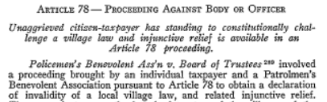
. . .

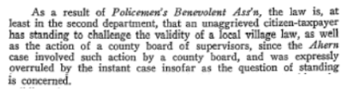

. . .

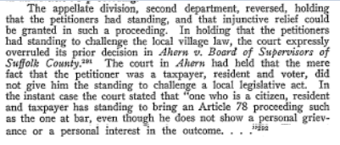

. . .

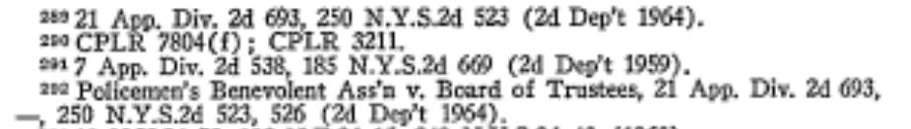

- The cases cited above does show that the second department does allow an unaggrieved citizen-taxpayer to challenge the Constitutionality of a local law and allows an unaggrieved citizen-taxpayer to challenge such a law pursuant to an Article 78 mandamus proceeding.
- In addition, in New York State's overview of Article 78 Practice and Procedure (see : http://onlineresources.wnylc.net/FairHearingResources/docs/an_overview_of_article_78_practice_and_procedure__05-21-09_.pdf), states the following :
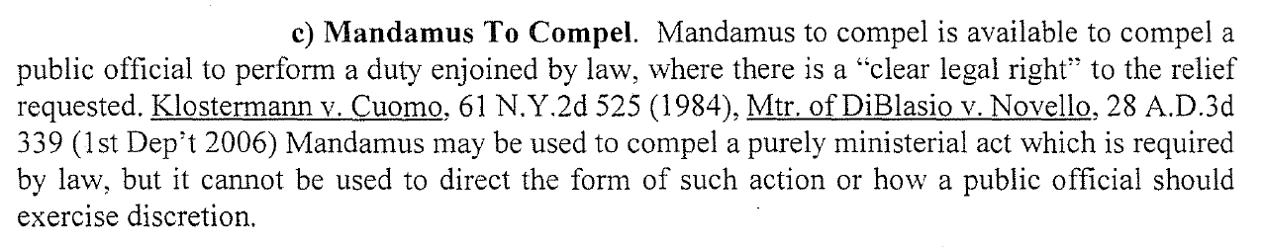
- The ministerial act requested in this proceeding is for the Respondent to rescind the Town's “Emergency Free Air Law” since State and Local Zoning laws were violated during its enactment and said law currently conflicts with both State and Local laws which violates the Fourteenth Amendment to the Constitution which guarantees equal protection of the laws.
- In this proceeding, the Petitioner alleges that the Respondent, the Town of Hempstead did not follow New York State and Town law when they enacted the “Emergency Free Air Law”.
- There are no disputed questions of material fact in this case, and this has been codified by the Respondent in his Motion to Dismiss whereas he did not dispute any material facts in his Motion to Dismiss.
- Consequently, as stated in Ahern v. Bd. of Supervisors : “It is well settled that where there is no disputed question of material fact but only an issue of law, the relief here requested may be awarded in a mandamus proceeding” (see: Matter of Ahern v. Bd. of Supervisors, 17 Misc. 2d 164, N.Y. Misc. 1959).
- The Respondent's Motion to Dismiss does not refute the allegation that the “Emergency Free Air Law” preempts State Law (as alleged in Petition statement 6).
- The Respondent's Motion to Dismiss does not refute the allegation that the “Emergency Free Air Law” preempts New York State Zoning Law (as alleged in Petition statement 7).
- The Respondent's Motion to Dismiss does not refute the allegation that the “Emergency Free Air Law” preempts the Town's zoning law (as alleged in Petition statement 8).
- The Respondent's Motion to Dismiss does not refute the allegation that the “Emergency Free Air Law” was not written to regulate land usage, as required by New York State and Town Zoning Law, but was written to cut a deal to settle a law suit (as alleged in Petition statement 9).
- It is important to note that the attorney for the Respondent, Joseph Ra, who is also the Town Attorney, advised the Town Board on the “Emergency Free Air Law” resolution saying the resolution was legal, but never provided any detailed reason for his position at the August 7th,2018 Public Hearing for this law or in his Motion to Dismiss this matter.
- The Respondent has spent over $75,000 of taxpayer money litigating the “Emergency Free Air Law” and its predecessor, the “Free Air Law” from which the “Emergency Free Air Law” was derived, but has not provided one material fact in this matter to support the law's legitimacy.
- In the Resolution proposing the “Emergency Free Air Law”, the preamble says the following :
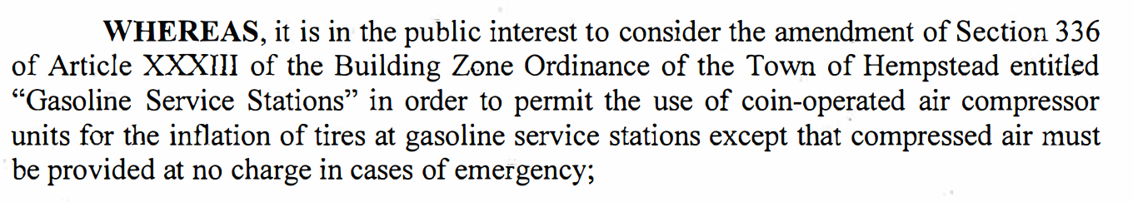
- Despite the Respondent claiming this resolution is in the public interest, the Respondent during the hearing of the “Emergency Free Air Law”, on August 7, 2018 never explained why this law is in the public's best interest, and refused to discuss it in any detail because it was a subject of pending litigation.
- But even when faced with the task of defending this legislation in a court of law (in this action), the Respondent has not provided one statement defending the legitimacy or need for the “Emergency Free Air Law”.
- In addition, in the Respondent's own hypothetical situation (if this matter were converted to a declaratory judgment action) he cites, Clark v. Town Bd. of Clarkstown, 28 A.D.3rd 642, 812 N.Y.S.2d 643, 645 (2nd Dep't, 2010), to convince the court that the Petitioner does not have standing.
- The problem for the Respondent is in Clark v. Town Bd. of Clarkstown, an administrative decision is being challenged and NOT the legitimacy of a local law.
- In the matter of Clark v. Town Bd. of Clarkstown the Petitioner is challenging an administrative decision dealing with the appointment of a Police Chief, and NOT the legitimacy of a local law.

- In Clark v. Town Bd. of Clarkstown, the court said:
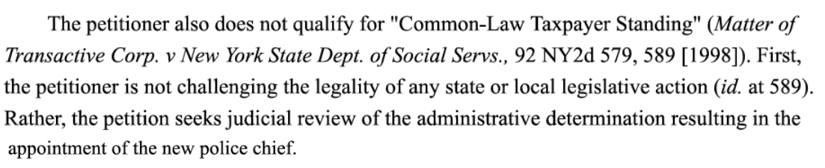
- This is not the case in this action, because the Petitioner is challenging the legality of a local legislative action, the “Emergency Free Air Law”.
- Also, in Clark v. Town Bd. of Clarkstown, the court said:
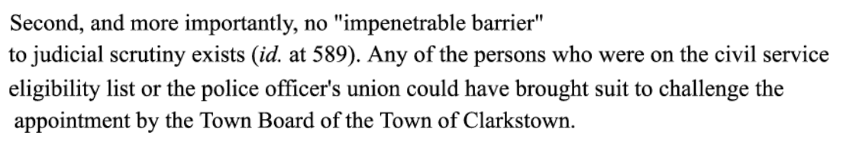
- The “impenetrable barrier” argument made by the Respondent is irrelevant because it has already been established in the Petition (items 27 through 33) and again in this document that a Citizen-Taxpayer does indeed have standing to challenge the Constitutionality of a Local Law in the second department.
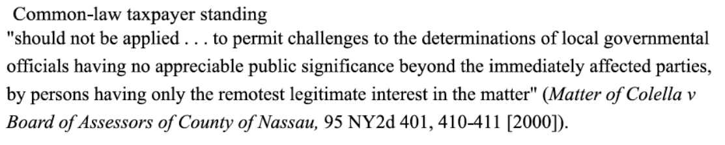
- And finally, in Clark v. Town Bd. of Clarkstown, the court said:
- This is also an irrelevant argument in this matter because the Petitioner in this action is NOT challenging a determination of local government officials (an administrative action), but the legality of a local legislative action.
- WHEREAS the Petitioner, Felix Procacci has shown that he has standing in this case and that an Article 78 of mandamus is appropriate, and the Respondent, Town of Hempstead has NOT SHOWN ANY EVIDENCE to support the legitimacy or need for the Town ordinance referred to as the “Emergency Free Air Law”, the Petitioner respectfully asks the court to reject the Respondent's Motion to Dismiss and provide an order that the Town of Hempstead rescind the “Emergency Free Air Law” and provide the costs incurred by the Petitioner for this action, totaling $475 ($210 for the index number, $45 for Notice of Petition, $95 for the RJI, and $125 for the process server). Details of these costs are attached hereto as Exhibit 2.
- Petitioner argues that the Respondent pay for the cost of this action because this zoning ordinance, the “Emergency Free Air Law” was enacted in bad faith, to settle litigation after the court issued an injunction on the Town's “Free Air Law” saying the Plaintiffs in that case would likely succeed based on the doctrine of preemption (see Exhibit 6 of the Petition).
- Instead of just simply rescinding the “Free Air Law”, which would have been in the public interest of the Town's taxpayers, the Respondent chose to appeal the decision for unspecified legal reasons, which led eventually to the negotiated illegal settlement which was to create the illegal “Emergency Free Air Law”.

DATED: Nassau County, New York
December _____, 2018

Respectfully submitted,

_______________________
Felix Procacci
Pro Se
1165 Barnes Street
Franklin Square, New York 11010
(516) 233-1562
EXHIBIT 1
St. John's Law Review
Issue 1, Volume 39, December 1964, Number 1
Page 1 of 3
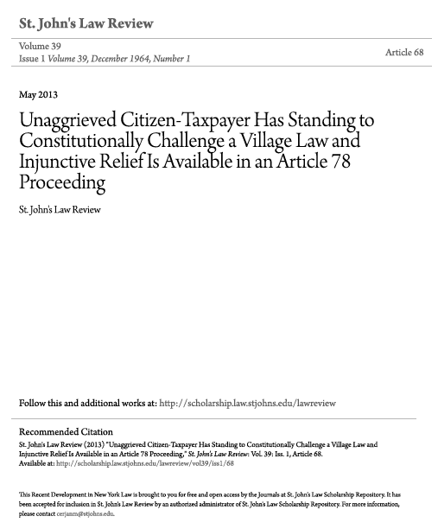
EXHIBIT 1 - continued
St. John's Law Review
Issue 1, Volume 39, December 1964, Number 1
Page 2 of 3
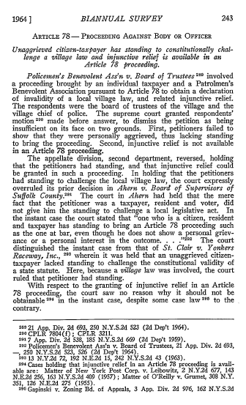
EXHIBIT 1 - continued
St. John's Law Review
Issue 1, Volume 39, December 1964, Number 1
Page 3 of 3

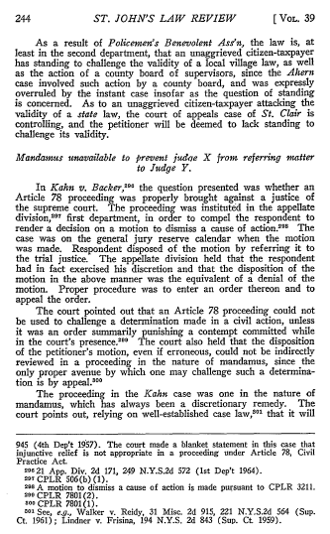
EXHIBIT 2
Petitioner's Expenses
for this Action


